Critical Analysis of Interfaces
Interface Evaluated: Naukri (naukri.com)
Hussein Ebrahim | MIT World Peace University, Pune | PRN 1032233294

1. Introduction
Naukri.com, launched in 1997 and operated by Info Edge, is India's longest-running and largest online job portal, serving both jobseekers and employers. Its scale and longevity make it a useful subject for interface critique: the site has accumulated nearly three decades of incremental features without a single unifying redesign, and the resulting interface shows the classic symptoms of that history — inconsistent visual language, competing calls-to-action, and workflows that prioritise monetisation touchpoints over the core job-search task.
This analysis focuses purely on interface design problems — learnability, usability, consistency, and related heuristics — rather than on backend engineering or business-model concerns, in line with the assignment brief. Each parameter below reflects direct interaction with the desktop site as a jobseeker, supplemented by patterns consistently reported by other users.

2. Evaluation Against Interface Design Parameters

Learnability
The homepage immediately communicates its primary purpose through the headline "Find your dream job now". A large search bar is placed in the centre, making it obvious that searching for jobs is the first action for new users.
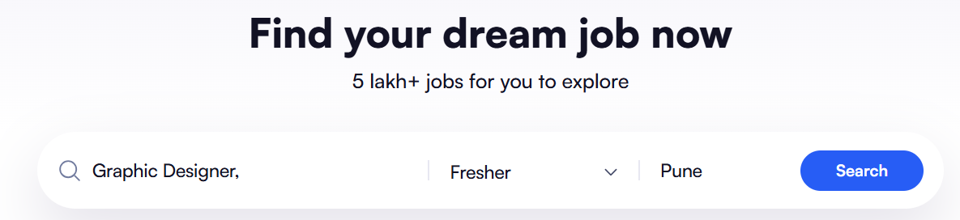

Usability
The search interface includes both a magnifying glass icon inside the search field and a separate blue "Search" button on the right. Since the magnifying glass is widely recognised as the symbol for initiating a search, having an additional Search button may create slight ambiguity for first-time users. Some users may wonder whether clicking the icon performs the search or whether only the blue button is functional. Making the icon decorative or allowing both elements to perform the same action with clearer visual cues would improve usability.
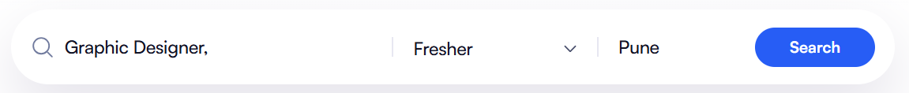

Use of Metaphors
Familiar icons are used throughout the interface, such as the magnifying glass for search, building for companies, house for remote jobs, and briefcase-related icons for job categories.


Navigation Structure
The top navigation clearly separates major sections into Jobs, Companies, Services, and For Employers, allowing users to move between different areas without confusion.

Visual Hierarchy
The largest text on the page is the heading followed by the search bar. Secondary information like category cards appears below, naturally directing the user's attention from top to bottom.
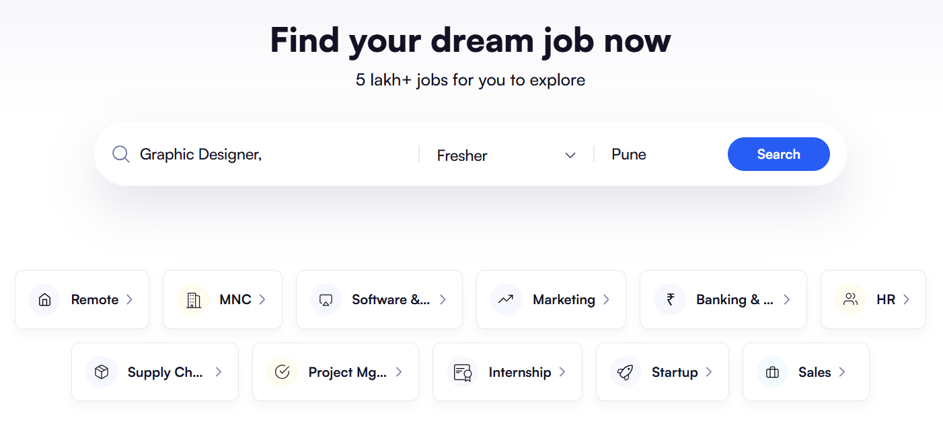
rr
rr

Accessibility
The interface is generally accessible due to its clean layout and high contrast between major headings and the white background. However, several pieces of secondary information, such as company ratings, review counts, hiring statistics and category labels, are displayed using relatively small font sizes and light grey text. Users with low vision or older users may find these details difficult to read without zooming in. Increasing the font size and improving the contrast of secondary text would make the website more accessible to a wider range of users.
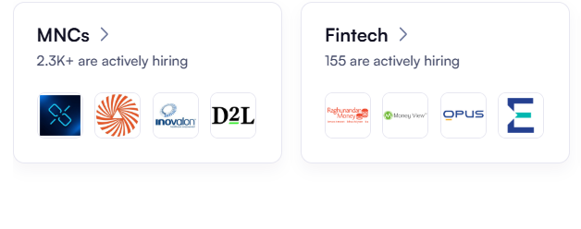

Responsiveness
Although responsiveness cannot be fully evaluated from static screenshots alone, the homepage layout suggests that the interface has been designed with responsive principles. Content is organised into modular cards with consistent spacing, and the navigation bar remains fixed while users scroll through the page. The interface maintains alignment throughout the page without overlapping or broken elements, indicating good responsiveness. Based on the observed layout, the design appears capable of adapting effectively across different screen sizes.
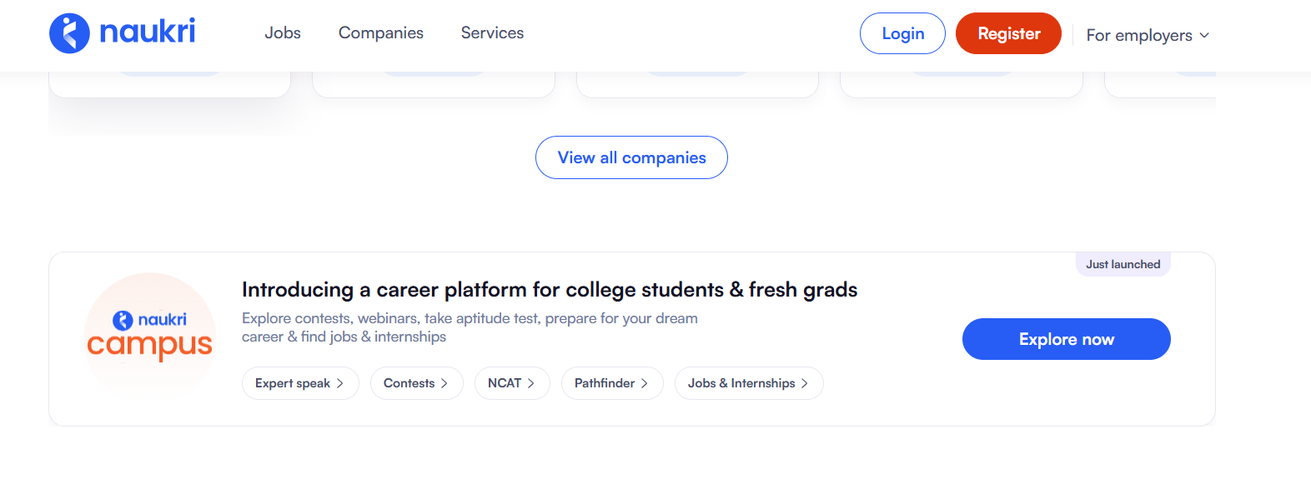

Efficiency of Interaction
The homepage allows users to begin their job search immediately without requiring registration or login. Essential search filters for job title, experience level and location are available directly on the landing page, reducing the number of steps needed to start searching. In addition, shortcut categories such as Remote, Internship, Startup, and Marketing enable users to quickly access popular job types without manually entering search terms. These features make the interaction efficient and reduce the time required to complete the primary task.
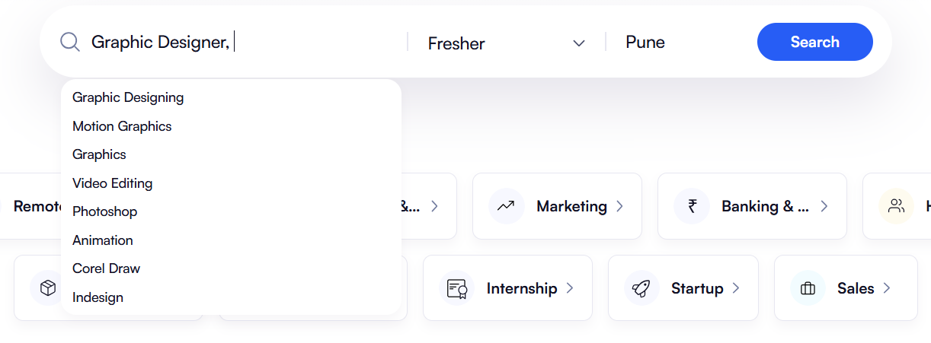

Feedback and System Status
The homepage provides limited feedback regarding user interactions because most actions have not yet been initiated. For example, there are no visible loading indicators, hover states, or progress messages that inform users about the status of the system before interacting with the website. While this is not a major issue on the homepage, providing clearer visual feedback during search initiation or page transitions would improve user confidence and make the interface feel more responsive.
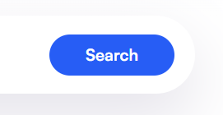

Error Prevention and Recovery
The homepage includes structured input fields, such as the experience dropdown, which helps minimise user input errors by restricting invalid entries. However, the homepage does not provide visible guidance about handling incorrect or incomplete searches before the user submits them. There are also no examples, placeholder suggestions or validation messages shown on the interface. Providing clearer guidance and immediate validation would help prevent user errors and improve the overall search experience.
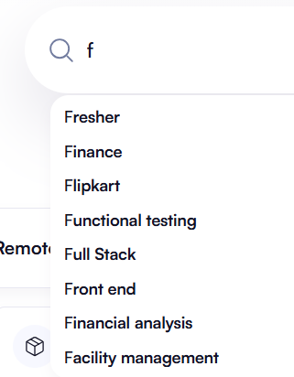
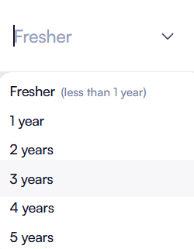

Aesthetic and Minimalist Design
This is apna's clearest weakness. The hero section is genuinely minimal and well-composed, but it is followed by an extremely long, repetitive stretch of city and category links that violates minimalist design outright — it adds volume without adding value for a human visitor, and (as noted under Consistency) some blocks appear duplicated within the same page.

Content Readability
The website presents information using large headings, readable typography and sufficient spacing between interface elements. Company information is grouped within individual cards, making it easy to distinguish one listing from another. Headings, ratings, reviews and action buttons are organised logically, allowing users to quickly scan relevant information without excessive effort. Overall, the content is presented in a clear and user-friendly manner.



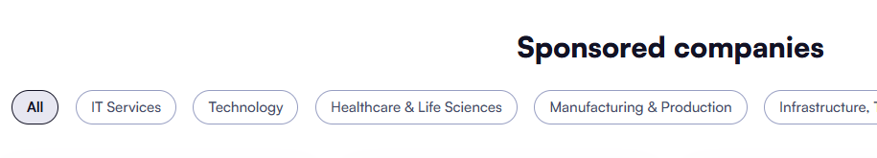

Search and Discoverability
The homepage excels at helping users discover relevant content. The search bar is positioned prominently at the top of the page and is immediately followed by commonly searched job categories such as Remote, Internship, and Startup. As users continue scrolling, additional sections including featured companies, sponsored companies and interview preparation resources provide multiple pathways for discovering jobs and career opportunities. This layered organisation makes important content easy to locate without requiring extensive navigation.
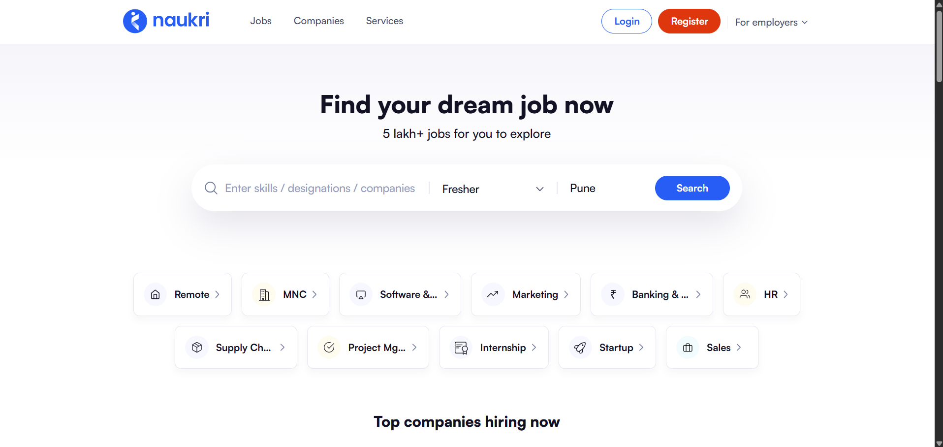

Performance Perception
The interface creates a strong perception of performance through its organised layout and structured presentation of information. Content is divided into separate sections that appear well balanced and easy to navigate, while the fixed navigation bar contributes to a smooth browsing experience. Although actual loading speed was not measured during this evaluation, the website gives the impression of being responsive and well optimised during normal interaction.

Trust and Credibility
The website establishes credibility by featuring recognised companies such as Infosys, Amazon, TCS, Accenture and Flipkart, along with company ratings, review counts and hiring statistics. The footer also contains important links including Privacy Policy, Trust & Safety, Fraud Alert and Help Centre, demonstrating transparency and reassuring users about the platform's legitimacy. These elements collectively increase user confidence and strengthen the website's professional image.
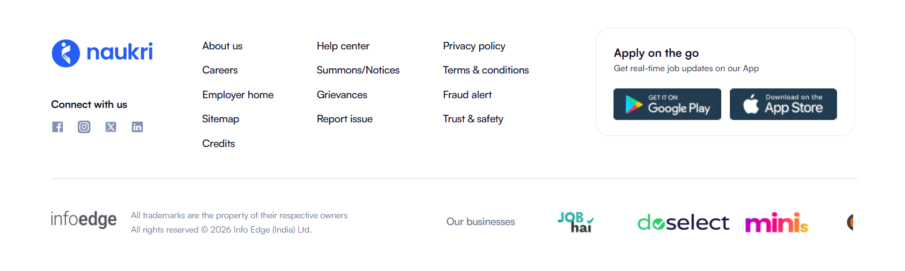

Personalization
The homepage offers several curated sections such as featured companies and interview resources; however, these recommendations appear to be generic because the user is not logged into an account. As a result, the content is the same for all visitors rather than being tailored to individual skills, preferences or previous searches. Introducing personalised recommendations for returning users would make the browsing experience more relevant and improve user engagement.
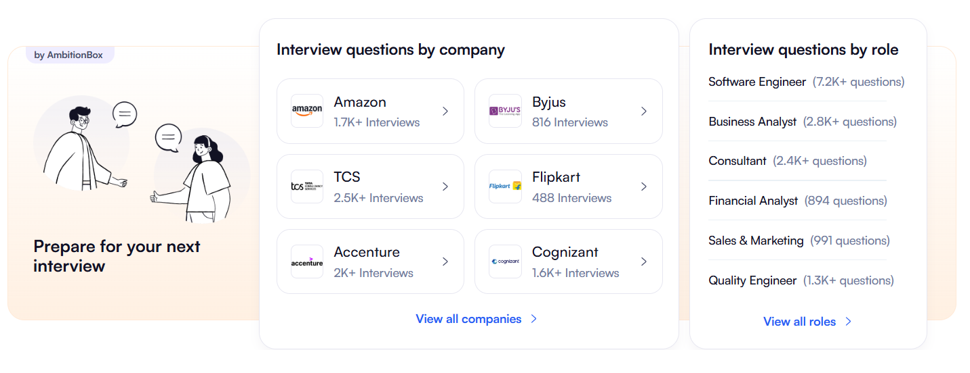

User Satisfaction
Overall, the homepage provides a positive first impression through its clean design, intuitive navigation and efficient search functionality. Most essential features are easy to locate, and the website successfully communicates its primary purpose. However, a few minor usability issues, such as the dual search indicators and the presence of multiple visually similar company sections, may create slight confusion for new users. Despite these small concerns, the interface offers an enjoyable and effective browsing experience.
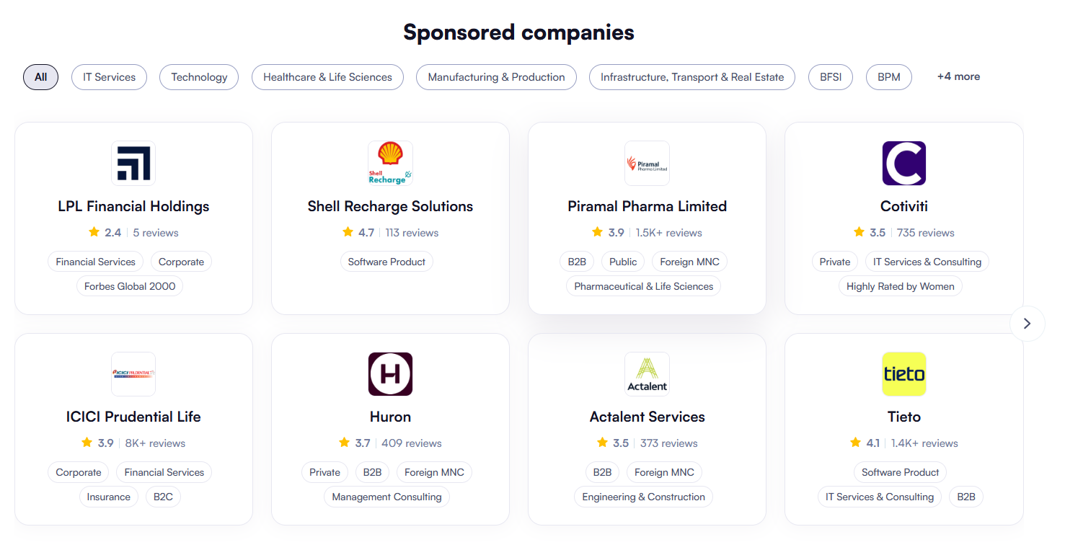

3. Evaluation Against Shneiderman's Eight Golden Rules
The interface is assessed below against Ben Shneiderman's eight golden rules of interface design, a widely used heuristic checklist for usability.
Golden Rule (Shneiderman) | How well it's met | Notes
1. Strive for consistency | Partial | Strong in the hero/testimonial areas; undermined by duplicated link blocks lower on the page.
2. Seek universal usability | Partial | Simple for the primary search task; small, low-contrast links limit access further down the page.
3. Offer informative feedback | Adequate | Little dynamic feedback needed given the largely static homepage; what exists behaves predictably.
4. Design dialogs to yield closure | Good | Search → results is a short, clear sequence with an obvious endpoint.
5. Prevent errors | Good | Separate employer/candidate login prevents a common cross-portal mistake.
6. Permit easy reversal of actions | Not evaluable | Homepage offers little state to reverse; would need results-page testing to assess fully.
7. Keep users in control | Good | No forced interstitials on the homepage; the user drives the one available action.
8. Reduce short-term memory load | Weak | Hundreds of unlabelled, ungrouped links ask the user to hold too much unstructured information at once.

4. Conclusion
Naukri.com's interface is functional at its core — search and filtering work, and the platform's scale gives it a job database few competitors can match — but the surrounding experience actively works against the user. Ad density, inconsistent visual language across sections, unclear feedback, and monetisation-driven interruptions all add friction to what should be a straightforward task: finding and applying to a job. The platform would benefit far more from an interface consolidation pass than from additional features.

Recommendations
- Unify typography, colour, and button styles across job-search, recruiter, and premium sections into one design system.
- Preserve filter state when a user navigates from a listing back to search results.
- Separate paid/sponsored content from core results with clearer visual distinction (labelling, spacing, or a dedicated rail).
- Add visible loading and confirmation feedback for key actions (apply, save, upload).
- Replace generic form errors with field-specific, actionable validation messages.
- Raise contrast and font size on secondary text (tags, dates, filter chips) to meet accessibility guidelines.

Interface Evaluated: Apna (apna.co)
Hussein Ebrahim| MIT World Peace University, Pune | PRN 1032233294

1. Introduction
Apna is an app-first Indian job platform aimed primarily at blue-collar, entry-level, and first-time jobseekers, alongside a growing white-collar user base, with over 5 crore reported job seekers and more than 1,000 enterprise employers on the platform. Because its target audience often has limited familiarity with dense web interfaces, apna's design choices are worth examining closely: the site gets the highest-stakes moment — the first search — right, but its homepage architecture below that point reveals a tension between designing for the human visitor and designing for search-engine indexing.
This analysis focuses purely on interface design problems — learnability, usability, consistency, and related heuristics — rather than on backend engineering or business-model concerns, in line with the assignment brief. Each parameter below reflects direct interaction with the desktop homepage as a jobseeker.

2. Evaluation Against Interface Design Parameters

Learnability
Apna demonstrates excellent learnability by immediately communicating its primary purpose through the bold heading "Your job search ends here." The search bar is prominently positioned in the centre of the hero section, allowing first-time users to understand the platform's main function without requiring any guidance. Supporting elements such as government recognition, enterprise logos and separate employer and candidate login options further help users understand the platform within a few seconds of visiting the homepage.

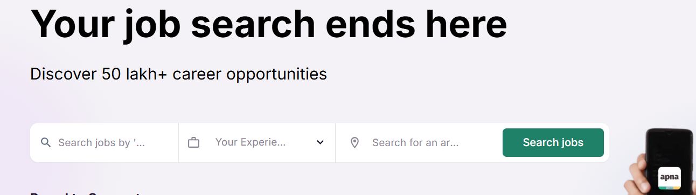

Usability
The search interface is simple and easy to use, allowing users to search by job title, experience and location from a single search bar. However, the placeholder text inside the search fields is truncated, displaying labels such as "Your Experie..." and "Search jobs by '...", which slightly reduces clarity for first-time users. Displaying the complete placeholder text would improve readability and reduce ambiguity during the search process.



Consistency
The interface maintains strong visual consistency throughout the homepage by using a uniform green-and-white colour palette, rounded cards and consistent typography. Buttons, company cards and job role cards follow the same design language, creating a cohesive appearance across different sections. This consistency makes the website feel organised and allows users to recognise interface elements quickly.
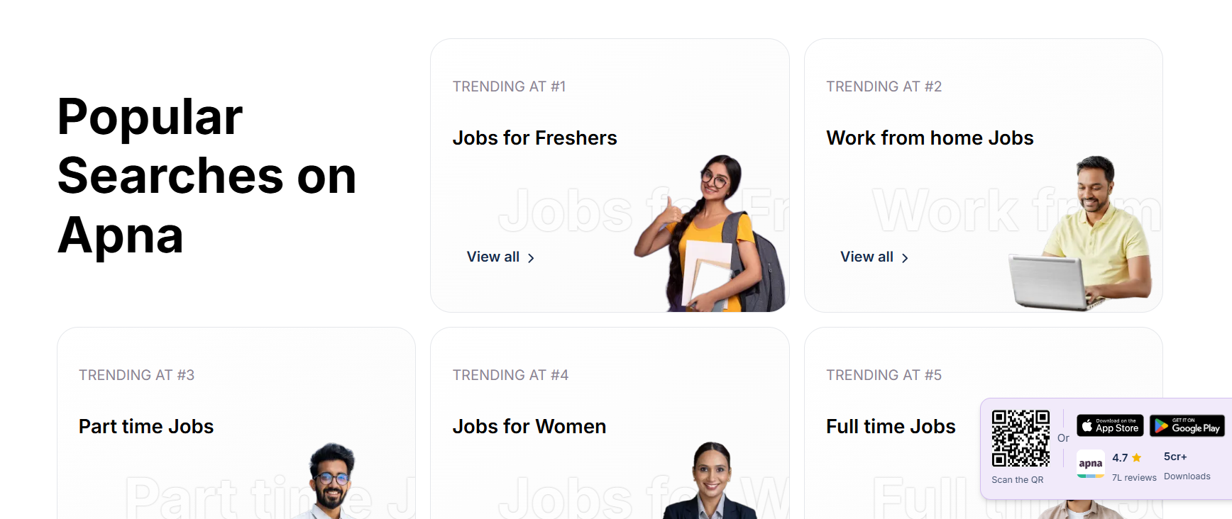

Use of Metaphors
The website effectively uses familiar interface metaphors that users can easily understand. Icons representing search, location, experience and different job categories follow common design conventions and require little explanation. These visual metaphors improve navigation by helping users quickly recognise different functions and categories.

Navigation Structure
The navigation structure is well organised and easy to follow. The primary navigation bar provides direct access to important sections such as Jobs, Job Prep, Contests, Degree and Resume Tools, while separate login options for employers and candidates clearly distinguish the platform's two primary user groups. Information on the homepage is arranged logically, beginning with job search before progressing to recommendations, companies, testimonials and additional resources.



Visual Hierarchy
The homepage follows a clear visual hierarchy that naturally guides the user's attention from the main heading to the search bar and then to supporting trust indicators such as government logos and enterprise partners. As users scroll, headings such as Popular Searches, Top Companies, and Trending Job Roles clearly separate different content sections. The use of font size, spacing and whitespace ensures that important information stands out while secondary content remains organised.
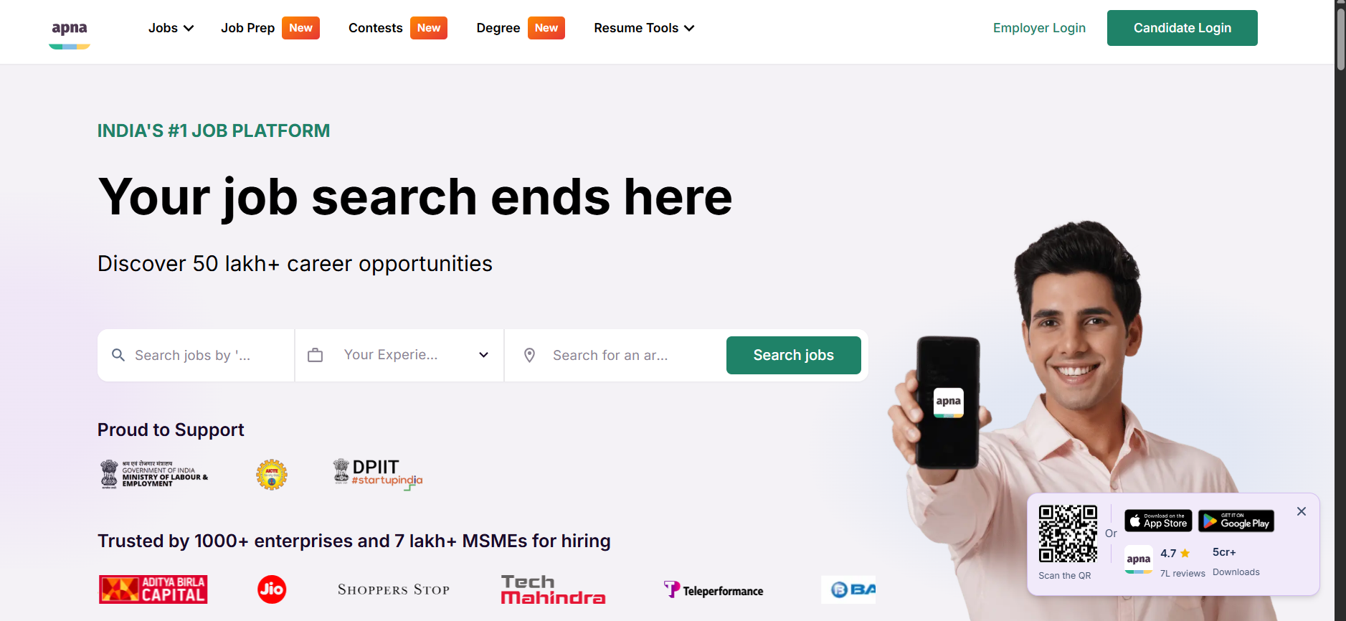

Accessibility
The interface generally provides good readability through strong colour contrast and large headings. However, some secondary information, including job opening counts, category labels and company descriptions, uses smaller font sizes that may be difficult for users with visual impairments to read comfortably. Increasing the size and contrast of supporting text would improve accessibility without affecting the overall design.
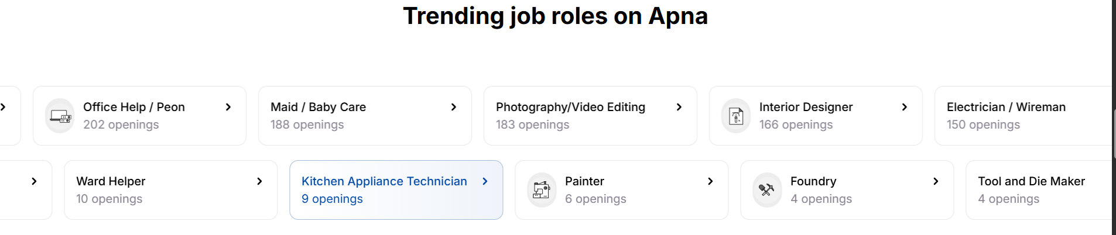

Responsiveness
The homepage is structured using responsive cards and flexible layouts that remain organised throughout the scrolling experience. Navigation remains accessible while the content is divided into evenly spaced sections, suggesting that the interface has been designed to adapt well across different screen sizes. Although responsiveness was not tested on multiple devices, the overall layout indicates good responsive design practices.
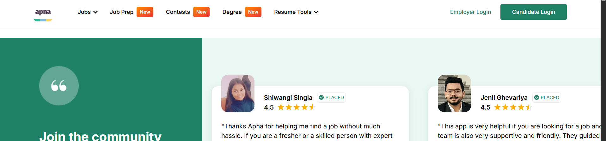

Efficiency of Interaction
Users can begin searching for jobs immediately without creating an account, reducing the effort required to perform the primary task. Essential search fields are presented directly on the homepage, while additional sections such as Popular Searches, Top Companies and Trending Job Roles provide quick shortcuts for discovering opportunities. These features reduce the number of clicks needed to reach relevant job listings.

Feedback and System Status
The homepage provides limited visual feedback because most interactive actions occur only after users begin searching or logging in. There are no visible loading indicators or confirmation messages displayed on the homepage itself. Providing clearer visual feedback during user interactions would increase confidence and make the interface feel more responsive.


Error Prevention and Recovery
The search interface reduces user errors by separating input fields for job title, experience and location. However, the homepage does not provide visible guidance or examples for entering search terms, nor does it display validation messages before users submit their search. Adding contextual hints or placeholder examples would help prevent mistakes and improve the search experience.
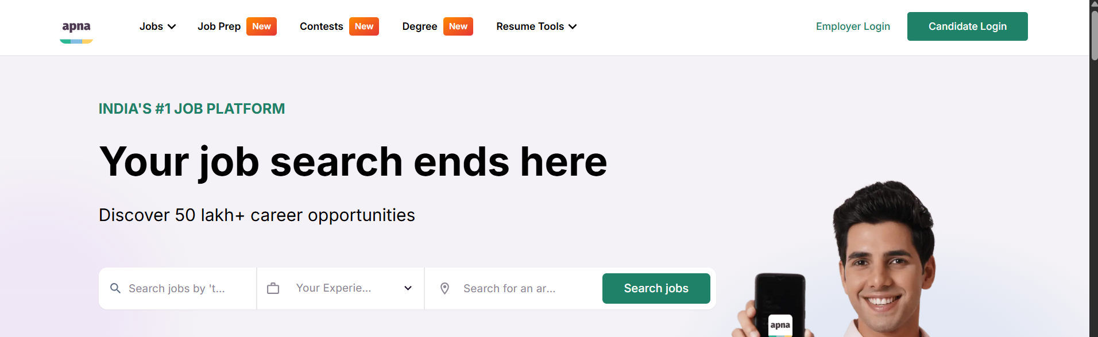

Aesthetic and Minimalist Design
The hero section presents a clean and modern design with generous whitespace and a clear focus on job searching. However, as users continue scrolling, the homepage becomes increasingly repetitive with multiple recommendation sections, company cards and large collections of links. These repeated sections reduce the minimalist appearance and make the page feel longer than necessary.
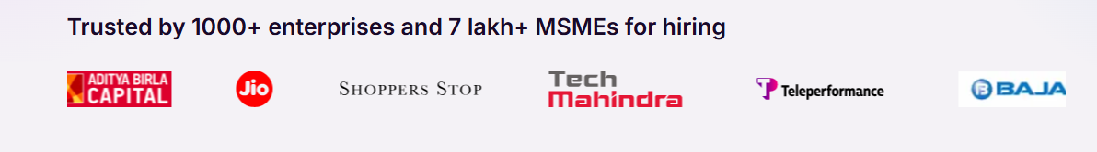

Content Readability
The website presents information using large headings, readable typography and well-spaced content cards that are easy to scan. Job roles, company names and descriptions are grouped logically, allowing users to distinguish information without difficulty. The consistent typography and spacing contribute to an overall pleasant reading experience.


Search and Discoverability
The homepage provides multiple pathways for users to discover employment opportunities. In addition to the prominent search bar, sections such as Popular Searches, Trending Job Roles, Top Companies and Job Categories encourage users to explore jobs without requiring specific search terms. This layered approach makes relevant content highly discoverable.
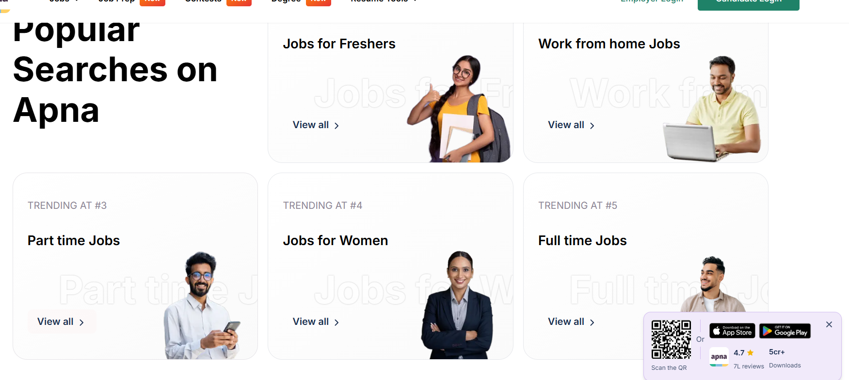

Performance Perception
The interface gives the impression of good performance through its organised layout and structured presentation of information. Sections are clearly separated and visually balanced, making navigation feel smooth during scrolling. Although loading speed was not measured, the interface appears responsive and well optimised from a user's perspective.

Trust and Credibility
Apna effectively establishes trust by displaying government recognition, enterprise partnerships and testimonials from successful users directly on the homepage. Company logos, user ratings and positive placement stories reinforce the platform's credibility and reassure visitors that it is a legitimate employment platform. These trust-building elements strengthen user confidence before they begin searching for jobs.
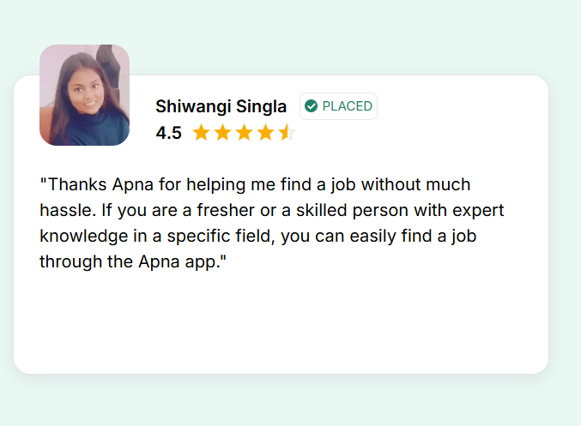

Personalization
The homepage primarily displays general recommendations such as popular searches and trending job roles instead of personalised suggestions tailored to individual users. Since the evaluation was conducted without logging into an account, the homepage offers the same content to all visitors. Providing personalised recommendations based on user preferences or previous searches would improve relevance and user engagement.
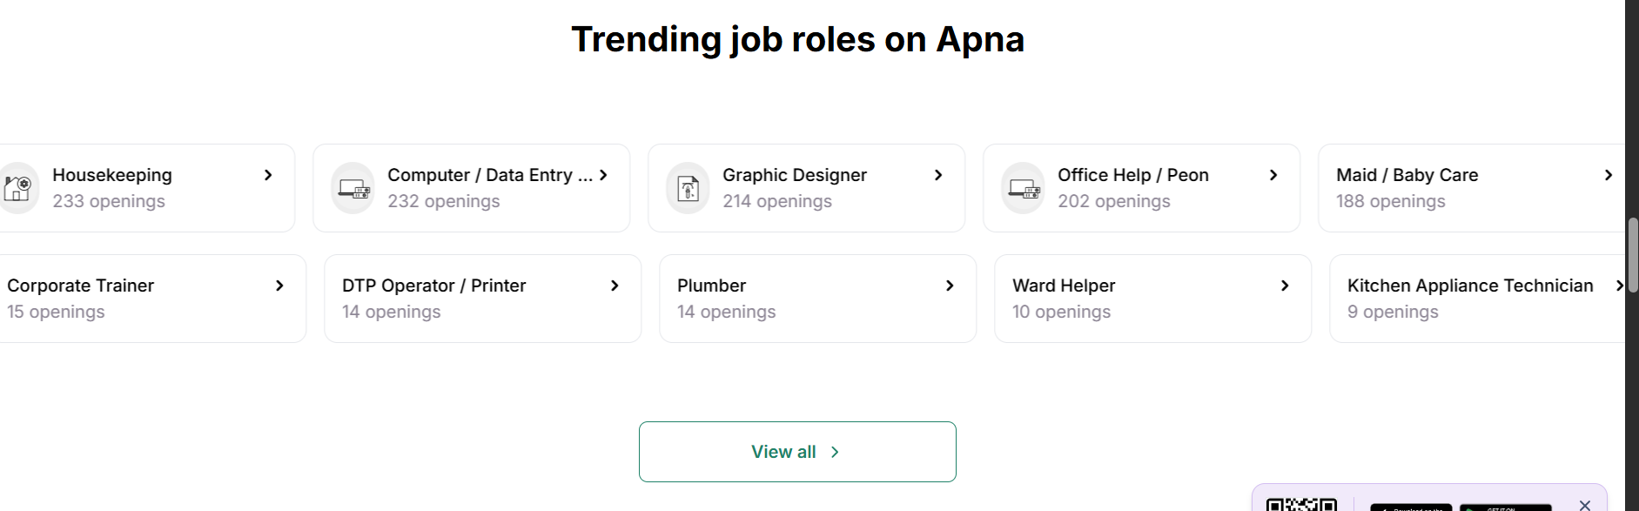

User Satisfaction
Overall, Apna provides a positive first impression through its intuitive search interface, professional appearance and strong trust-building elements. However, the persistent floating QR code widget, repetitive recommendation sections and unusually long footer slightly reduce the overall user experience. Despite these minor usability issues, the platform successfully supports its primary goal of helping users discover job opportunities efficiently.
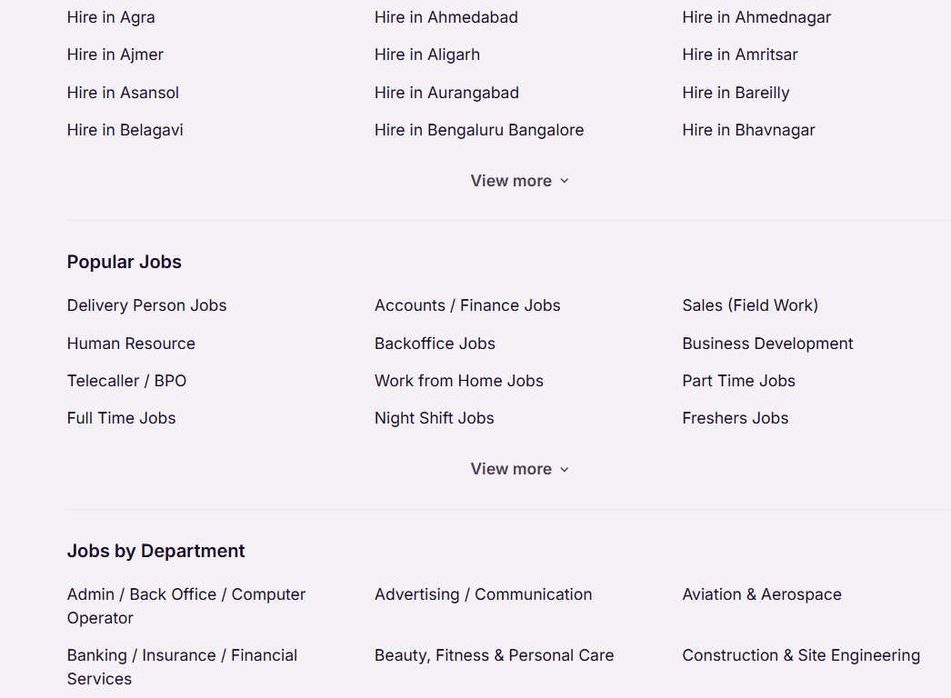

3. Evaluation Against Shneiderman's Eight Golden Rules
The interface is assessed below against Ben Shneiderman's eight golden rules of interface design, a widely used heuristic checklist for usability.
Golden Rule (Shneiderman) | How well it's met | Notes
1. Strive for consistency | Weak | Type, colour, and button styles vary noticeably between the job-search, recruiter, and premium-service sections.
2. Seek universal usability | Partial | Core search works for most users, but low-contrast text and inconsistent keyboard support limit access for some.
3. Offer informative feedback | Weak | Loading and confirmation states are minimal and easy to miss beside ad content.
4. Design dialogs to yield closure | Weak | The application flow's step count varies per listing and rarely gives a clear "you're done" moment.
5. Prevent errors | Partial | Basic form validation exists, but error messages are often generic rather than actionable.
6. Permit easy reversal of actions | Partial | Filters are not preserved when navigating back from a listing, effectively penalising exploration.
7. Keep users in control | Weak | Interstitials (profile prompts, upsell modals) frequently interrupt a user-initiated task.
8. Reduce short-term memory load | Weak | Loss of filter state and inconsistent apply flows force users to re-remember and re-enter prior choices.

4. Conclusion
Apna's interface is at its best in the moments it was clearly designed with care: the hero search, the employer/candidate login split, and the trust-building testimonial section are all clean, purposeful, and appropriate for the platform's audience. The weakness is structural rather than cosmetic — large stretches of the homepage are built as static link inventories for search-engine crawling rather than as navigable content for a human visitor, and this undermines the minimalism, readability, and memory-load principles that the hero section otherwise respects.

Recommendations
- Replace the flat city/department link lists with a searchable or collapsible filter component that serves the same discovery purpose without the visual and cognitive overload.
- Remove or consolidate the duplicated link blocks appearing more than once on the same page.
- Introduce clear section headings and grouping (with adequate contrast and font size) wherever link-dense content is retained for SEO purposes.
- Surface basic filters (location, salary range, work type) directly in or near the hero search, rather than requiring a results-page visit to discover them.
- Extend the visual care given to the hero and testimonial sections to the rest of the page, so first-time desktop visitors form their impression from the platform's best design work rather than its weakest.

